Dyfi Wildlife Centre

Using the visitor centre web application

**Author:** Michael Male ([mim39@aber.ac.uk](mailto:mim39@aber.ac.uk))

**Version:** 1.0 RELEASE

**Date:** 2nd May 2020

# Disclaimer

**Dyfi Wildlife Centre: Web App** is a product licensed under the [Apache 2.0 License](https://www.apache.org/licenses/LICENSE-2.0). It may be liable to the [Aberystwyth-Bangor Common Intellectual Property Policy](https://www.aber.ac.uk/en/hr/policy-and-procedure/au-and-bu/intellectual-property/).



This manual is licensed under a [Creative Commons Attribution-ShareAlike 4.0 International License](https://creativecommons.org/licenses/by-sa/4.0/).

# Introduction

## Purpose of this Document

This document is designed to be a quick overview and reference to using the Dyfi Wildlife Centre web application, provided via Aberystwyth University Department of Computer Science in May 2020. This web app has been designed for deployment onto a local computer, connected to a local area network. However, with a few tweaks, it can be designed to be deployed onto the World Wide Web, via a server hosting service, for example.

This document is designed for staff and volunteers at the Montgomeryshire Wildlife Trust, and contains sensitive information, such as default password. Do not disseminate this document outside of the organisation.

## Support Contacts

Until 30th June 2020, an ad-hoc support service can be provided by Michael Male, who can be e-mailed on [mim39@aber.ac.uk](mailto:mim39@aber.ac.uk). After that date, you may be able to get support from a contractor who specialises in Java and database engineering.

# System Requirements

This software is designed to run on a computer that is connected to the Dyfi Wildlife Centre’s local area network. The computer must have **Java** installed. It can be downloaded [here](https://www.java.com/ES/download/).

The software also utilises [**PostgreSQL**](https://www.postgresql.org/download/), a database software. Please ensure this is installed, this is a cross-platform application and scripts should be made available to run on your computer and install relevant dependencies, as well as initiate a version of the database.

All major operating systems support Java and PostgreSQL, although setup instructions may differ for each one of them. An installation script will be created for Windows and macOS. The software works best on the [Firefox](https://www.mozilla.org/en-GB/firefox/new/) or [Google Chrome](https://www.google.com/chrome/) web browsers; however, it should run on any modern web browser, that supports HTML 5.0 and JavaScript. A stable internet connection is required in order to access the Google Maps component.

# Initial setup

Before running the program, one must ensure that the computer has all dependencies outlined in the System Requirements section. A pre-install script has been provided with the software, in the *Installers* folder. Click the script corresponding to your operating system. This script sets up the database for use with the application, and ensures the correct privileges are set. It includes some dummy data that can be removed from the app.

Once the script is complete, you’re ready to go. Double-click the JAR file labelled ‘Dyfi Wildlife Centre’ and a command prompt window should load, this generally shows diagnostic information that could be useful should you run into an error. Leave this command prompt window open and, once messages stop appearing, open a web browser and navigate to <http://localhost:8080>. You should be presented with the home page.

# Navigation

## Homepage

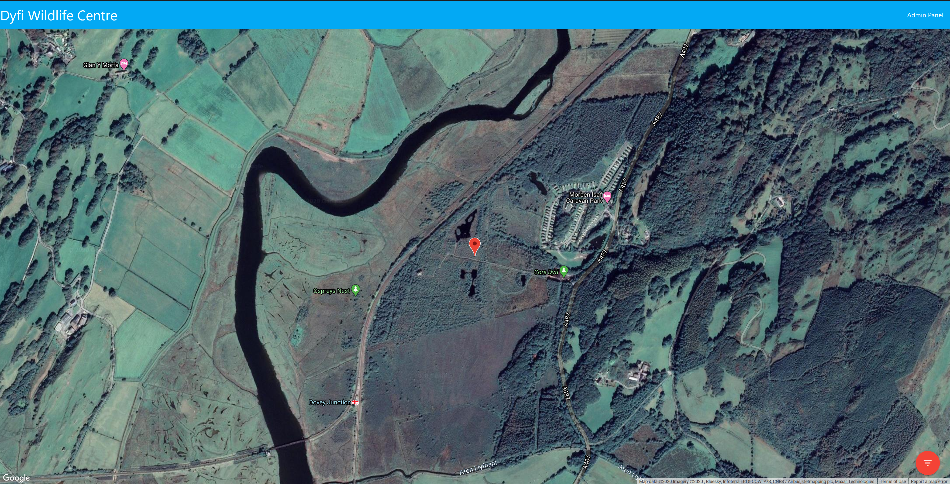

Figure - Homepage of the Dyfi Wildlife Centre Web App

This is the first page that will appear when you open the app, showing a Google Maps satellite view of the area surrounding the Dyfi Wildlife Centre. There are a few options and buttons that can be pressed to perform certain actions:

* **Home button** – Clicking the title, labelled *Dyfi Wildlife Centre*, brings you back to the home screen.
* **Admin panel button** – Clicking the admin panel takes you to the login page for the admin panel, which will be expanded on in a later subsection.
* **Filter button** – The red “floating action button” in the bottom right of the screen is used to show and hide different points of interest based on their filters. When you hover over the button, four options appear:
  + **All** – Show every point of interest
  + **Businesses** – Show local businesses that have been marked on the map
  + **Transport** – Show transport locations, such as bus stops or train stations, that have been marked on the map
  + **Wildlife** – Show anything marked on the map as a wildlife hotspot.
* **Marker** – The marker in this screenshot is centred on the *Cors Dyfi* nature reserve. Clicking on it comes up with an information popup,

## Admin Panel

The admin panel is where you can add, edit, or delete points of interest, as well as add and remove users.

## Login

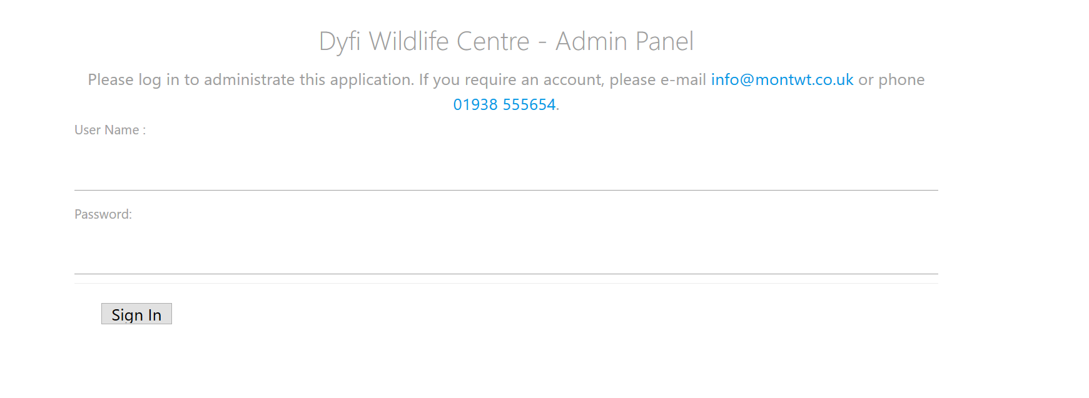

Figure - Admin Panel Log-in screen

If this is your first time using the app, the default login details are below:

**Username:** dyfi_admin

**Password:** dyfi_admin

For security reasons, it is recommended that a new account is created, and this account is then deleted.

## Home screen

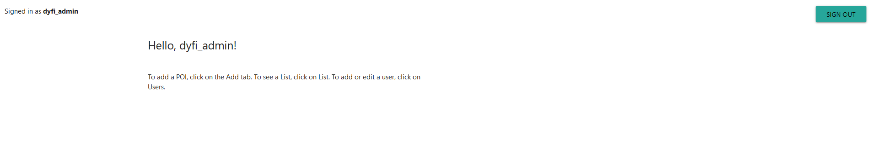

Figure - Admin Panel Home screen

The home screen is a simple dialog, that informs you as to who is logged in. A sub-menu has now appeared that can be used to navigate through the admin panel.

## Add

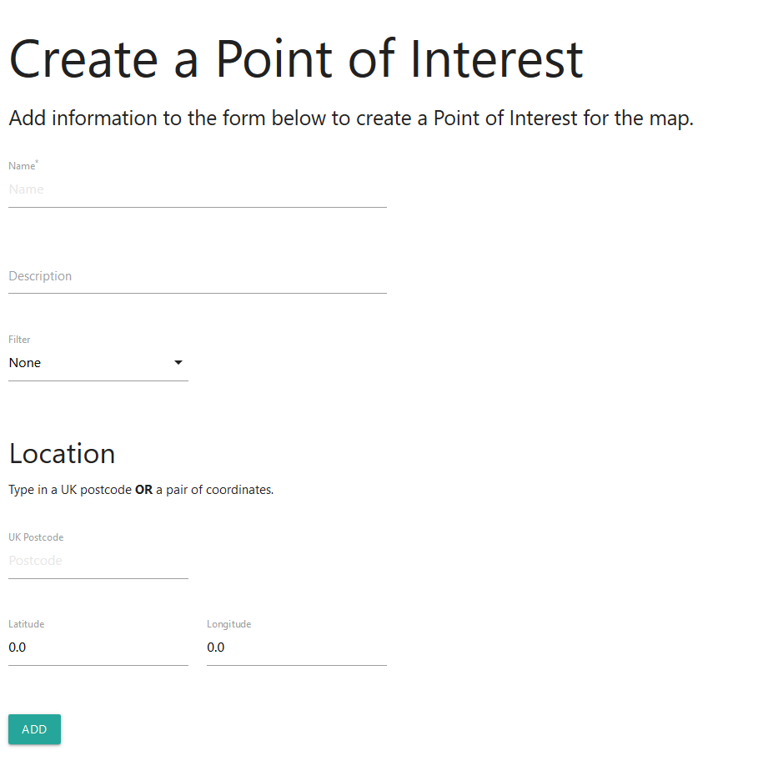

Figure - Create a Point of Interest

Use this form to add a Point of Interest. This will save a Point of Interest onto the database and then redirect you to the homepage, where you can see it. The following parameters are explained in detail below:

* **Name** – This is a required field, for the name you want to give to the Point of Interest.
* **Description** – This is a large text area that can be used to provide a longer description of the Point of Interest. This isn’t necessarily required, however is useful to give further information within the popup.
* **Filter** – A selection of one of three filters can be made in this field. You can also pick no filter.
* **Location** – The location fields can take one of two parameters. It cannot take both.
  + **UK Postcode** – If you have a valid postcode for a Point of Interest that is in the United Kingdom, enter it here. This will then go through a process called *Geocoding*, where a server containing the coordinates that each postcode corresponds to is queried and the coordinates are updated in the database. Note that, unless
  + **Latitude/Longitude** – This field takes a latitude/longitude pair, written in the decimal degrees format.

This is then added to the database and can be edited or deleted later.

## List

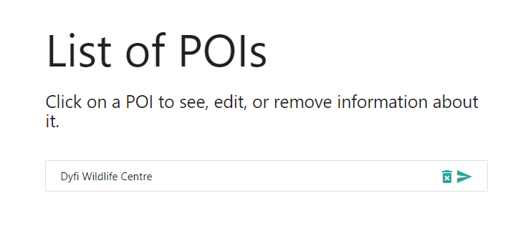

Figure - List of POIs

This shows the list of points of interest that are currently in the database. The screenshot only shows one, the Dyfi Wildlife Centre, which is of note as the map will centre on the location regardless of if there is a marker there. Each entry in the list has two icons. The bin icon allows you to delete a point of interest directly from that screen, and the send icon redirects you to the **Edit a Point of Interest** dialog, where you can edit various features.

## Users

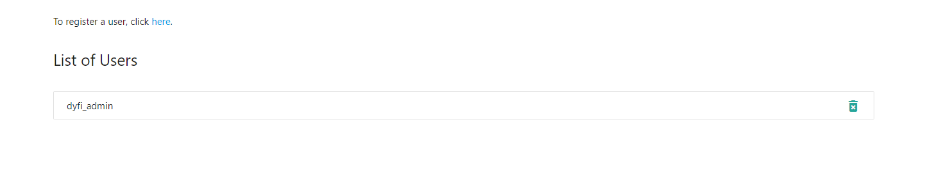

Figure - User list

By clicking on the Users tab, you’re redirected to the list of users. This will show a list of all users currently registered on the application. To delete a user, simply click on the bin icon. Take care not to delete yourself, particularly if you are the only user registered, as it could be difficult to re-register.

## Register a User

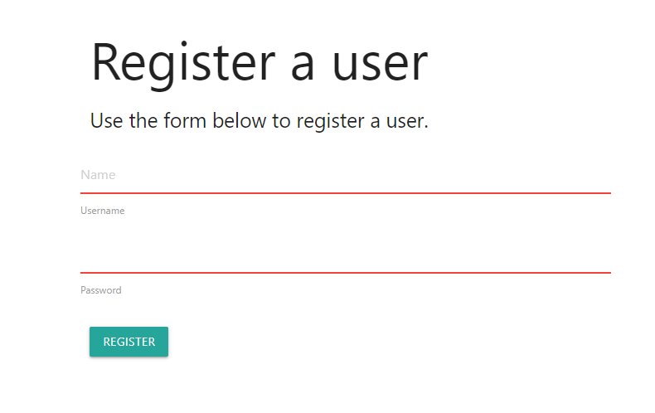

Figure - Register a User

This is a simple form that allows you to register another user, which is useful if you do not want to share passwords. Upon clicking ‘Register’, the given password is encrypted, and added to the database. You can now log in with that username.